Applications Anywhere Anytime
Welcome to myAccess!  [Insert your application name] is now available for use through myAccess! This means that you can access [Insert your application name] anytime, anywhere as long as you have internet access.  To get started simply logon to myAccess using your zID. On your initial logon you will be prompted to download and install a Citrix Receiver which will enable the service. If you need any help please refer to the myAccess user guides or else contact the IT Service Centre for assistance. | 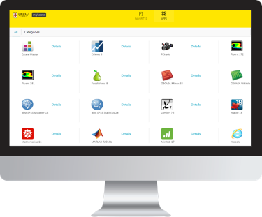
To optimise the performance of myAccess save your datasets to your H: drive. We have created a myAccess File Manager application to help you transfer datasets to and from your H: drive.
It is important to note that data classified by the UNSW Data Classification Standard as ‘Sensitive’ or ‘Highly Sensitive’ cannot be accessed managed or transmitted via the service.
Please contact the IT Service Centre for any other issues.
Most importantly, we welcome your feedback! Tell us what works, what doesn’t – how we can improve the service by contacting us.

Kind Regards,

myAccess Team

